22424313
1a.
?crabs

The crabs data frame has 200 rows and 8 columns, describing 5 morphological measurements on 50 crabs each of two colour forms and both sexes, of the species Leptograpsus variegatus collected at Fremantle, W. Australia.

b.
data("crabs")
str(crabs)

c.
table(crabs$sp,crabs$sex)

d.
barplot(table(crabs$sp,crabs$sex),
main = "Group Composition by Species and Sex",
xlab = "sex",
ylab = "Number of crabs",
col = c("red","blue"))

e.
The dataset is perfectly balanced with 50 males and 50 females of species

2a.
boxplot(BD ~ sp + sex,
data = crabs,
main = "Side-by-Side Boxplot of Body Depth",
xlab = "Species and Sex",
ylab = "Body Depth",
col= c("red","lightpink","lightblue","lightgreen"))

b.
It can be observed that, there are no extreme outliers. By comparing the central tendency (median) Males tend to have larger body depth than females within the same species. And between Species, One species generally shows slightly larger medians overall.
Variability between groups
Male groups usually show slightly greater variability.
Some species may display more spread than others.
Female groups typically have more compact distributions (smaller IQR)

3a.
par(mfrow=c(1,2))
hist(crabs$CL[crabs$sp == "B"],
main = "Carapace Length - Species B",
xlab = "Carapace Length",
col = "lightblue")

hist(crabs$CL[crabs$sp == "O"],
main = "Carapace Length - Species O",
xlab = "Carapace Length",
col = "lightpink")
par(mflow=c(1,1))

b.
Distribution
The distributions are approximately bell-shaped.
They appear fairly symmetric.
No extreme long tails are visible.
Skewness
Neither species shows strong skewness. Both are close to symmetric distributions, indicating that extremely large or small carapace lengths are uncommon.
Modality
Both species show unimodal distributions (one clear peak).
There is no evidence of bimodality within each species.

4a.
aggregate(cbind(FL, RW, CL, CW, BD) ~ sp + sex,
data = crabs,
FUN = mean)
b.

5a.
measurements <- crabs[, c("FL", "RW", "CL", "CW", "BD")]
pairs(measurements,
main = "Scatterplot Matrix of Crabs Measurements",
pch = 19,
col = "lightpink")

b.
Most pair of variables are strongly positive correlated. That is the pair between CL vs CW, FL vs RW and BD vs CW.
This means that as one measurement increases, the other tend to increase too.
Strength – Correlations among most variables are strong, especially CL, CW, and BD (body size indicators).
Nature – Relationships are approximately linear, as the points form a roughly straight diagonal line in each scatter plot.
Outliers – There may be slight variation depending on species (species variable) or sex (sex variable), which could cause some spread in the points.

6.
The crabs data frame has 200 rows and 8 columns, describing 5 morphological measurements on 50 crabs each of two colour forms and both sexes, of the species Leptograpsus variegatus collected at Fremantle, W. Australia.
The variables are;
Sp- Species which are B or O for blue or orange and are factors
Sex factors
Index- integer
FL- Frontal lobe size (Numeric)
RW – Real width (Numeric)
CL- Carapace length (Numeric)
CW- Carapace width (Numeric)
BD- body depth (Numeric)

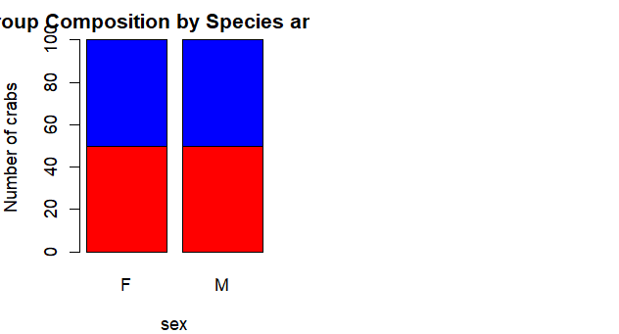
The figure above is perfectly balanced with 50 males and 50 females of species.
